INSTRUCTIONS FOR BLOOMBERG TERMINAL (BB231) SIGN UP
FALL 2021

- Use of the Bloomberg Terminal Room (BB231) is to complete work assigned by your Professor or to complete the Bloomberg certification. This room is not to be used as a meeting space.

- For fall 2021, students will be able to use the both remotely and in person. Only ONE student may use the terminal at a time. ALL students are required to reserve the use of the terminal by following the directions below.

- Students may submit a calendar request to use the room for no more than 2 hours at a time.

- To sign up for a time slot, submit a calendar request (through your TCNJ Gmail account).

- Sign in to your TCNJ Gmail Account, open the calendar in your Google Apps.

- Select date, start and end time.

- In the meeting title, enter your full name, TCNJ email address and in person (if you are going to physically in the room) or remote (if you are going to use the terminal remotely).

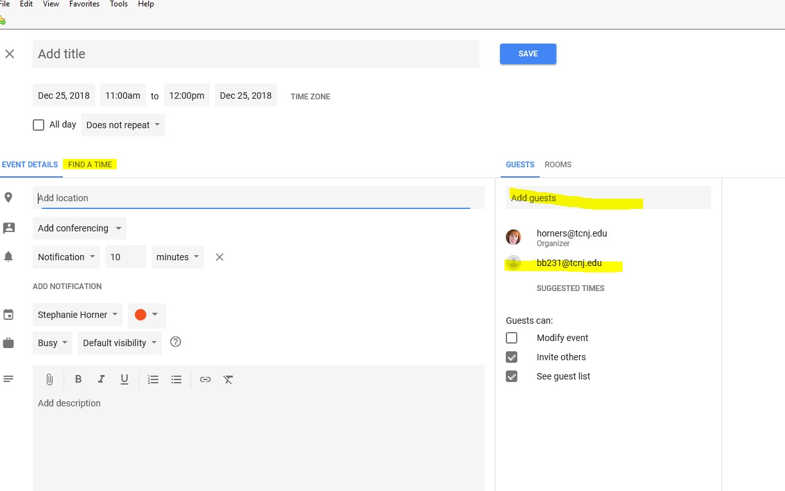
- Click on “More Options” and add a guest “bb231@tcnj.edu”. You can click on the “Find A Time” tab to see if there is a conflict (if it is grayed out there is another booking). If you request a time that is already booked your request will be denied and you will be sent an email to choose an alternate date/time.

- Click on “Save”. The request will be sent.

- The calendar is checked frequently throughout the day. Your calendar request should be approved within 2 business hours. The calendar is only monitored during normal business hours so should you want to sign up for an evening or weekend time, please be sure you do so Monday through Friday between 8:00 am and 4:00 pm.

- Once your reservation is confirmed, you will be emailed instructions for accessing the terminal remotely if you chose remote as your option.

- If you are creating a new account, you will need to follow the instructions below and then email Dr. Choi at choi@tcnj.edu to request that she approve your account. You should do this at least 1 business day prior to your scheduled time.

Students and faculty that do not have an existing Bloomberg Terminal login, can request a Bloomberg username and password at our BMC web portal: https://portal.bloombergforeducation.com/. You will then need to notify your professor to go in and approve your new username and password.

- Any issues or questions regarding BB231, please email bb231@tcnj.edu.

